Project -9

How to automatically trigger the job in Jenkins using pipelines integrating with GitHub

Dashboard:

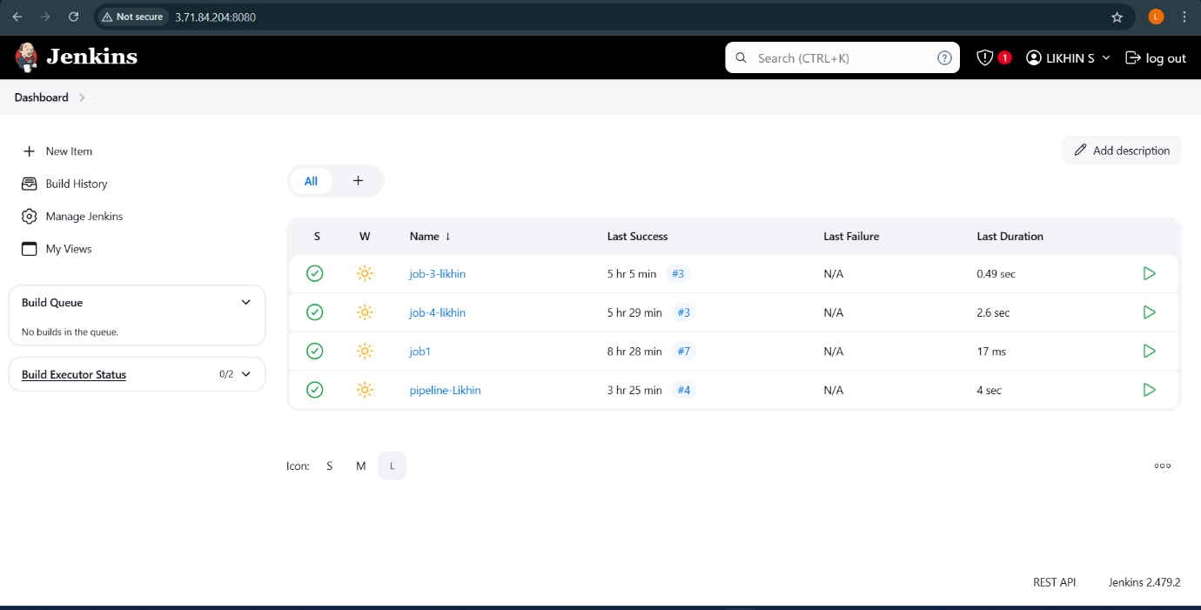

Creating Webhook:

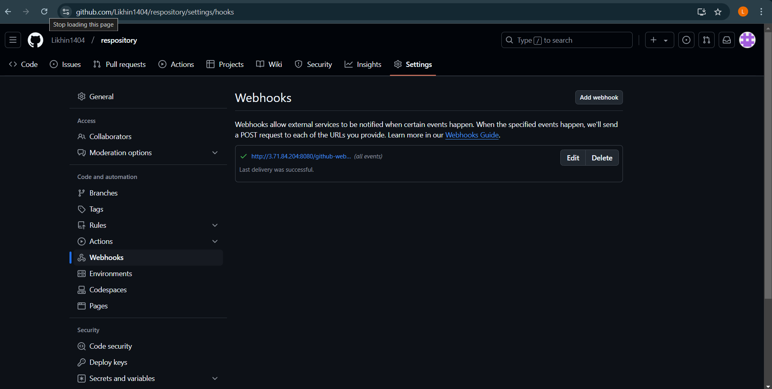

Status:

Stage logs: 